Task 7
- Division Handle
package task7;

import java.util.Scanner;

public class Divisionhandle {

public static void main(String[] args)
{
try
{
Scanner s = new Scanner(System.in);

System.out.println("Enter the first interger");
int a = s.nextInt();
System.out.println("Enter the second interger");
int b =s.nextInt();
int res = a/b;
System.out.println("The result of the division is:" +res);
}

catch(ArithmeticException e)
{
System.out.println("The second integer cannot be zero please input a valid number");
e.printStackTrace();
}
}

}

O/p:

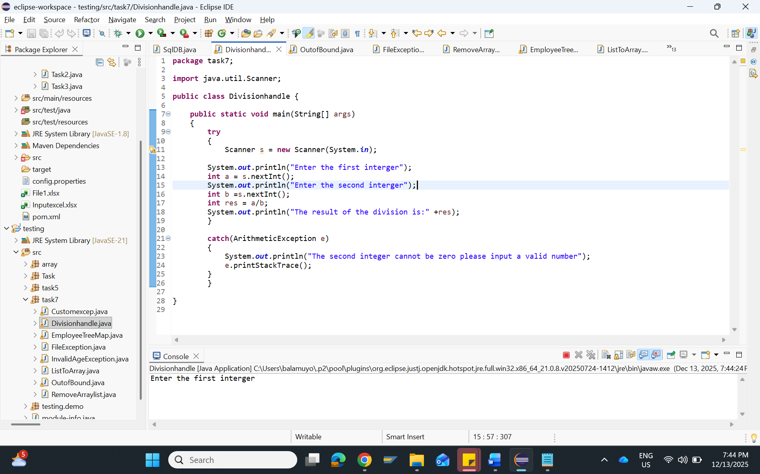

2. OutofBoundException:
package task7;

import java.util.Scanner;

public class OutofBound {

public static void main(String[] args)
{
Scanner input=new Scanner(System.in);

int[] a= new int[3];
System.out.println("Enter 3 integers for array");
a[0] =input.nextInt();
a[1] =input.nextInt();
a[2] =input.nextInt();
System.out.println("Enter the string");
String text = input.next();

try
{

System.out.println("The third element in the array is:" +a[3]);

}
catch(ArrayIndexOutOfBoundsException e)
{
System.out.println("ArrayIndex error catched");
e.printStackTrace();
}
try
{
System.out.println(text.charAt(9));
}
catch(StringIndexOutOfBoundsException e)
{
System.out.println("StringIndex error catched");
e.printStackTrace();
}

}
}
O/P:
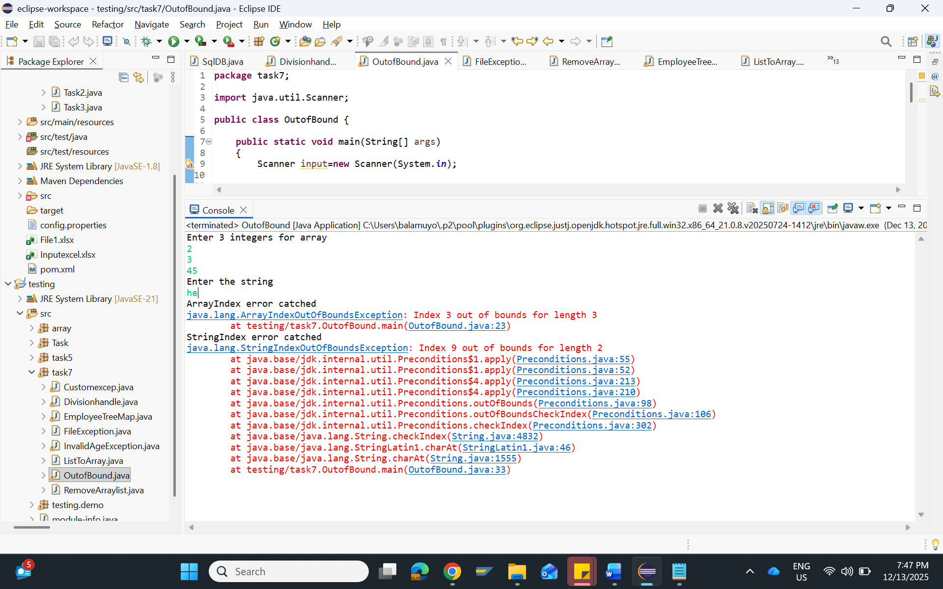

3.InvalidAgeException
public class InvalidAgeException extends RuntimeException
{

public InvalidAgeException(String msg)
{
super(msg);
}
}
Main Program:
package task7;

import java.util.Scanner;

public class Customexcep {

public static void main(String[] args)
{

Scanner input = new Scanner (System.in);
try
{
System.out.println("Enter the age");
int a = input.nextInt();
if (a<18)
{
throw new InvalidAgeException("....Age must be above 18....");
}
else
{
System.out.println("Age is accepted");
}
}
catch(InvalidAgeException e)
{
System.out.println(e.getMessage());
}

}

}

O/P:
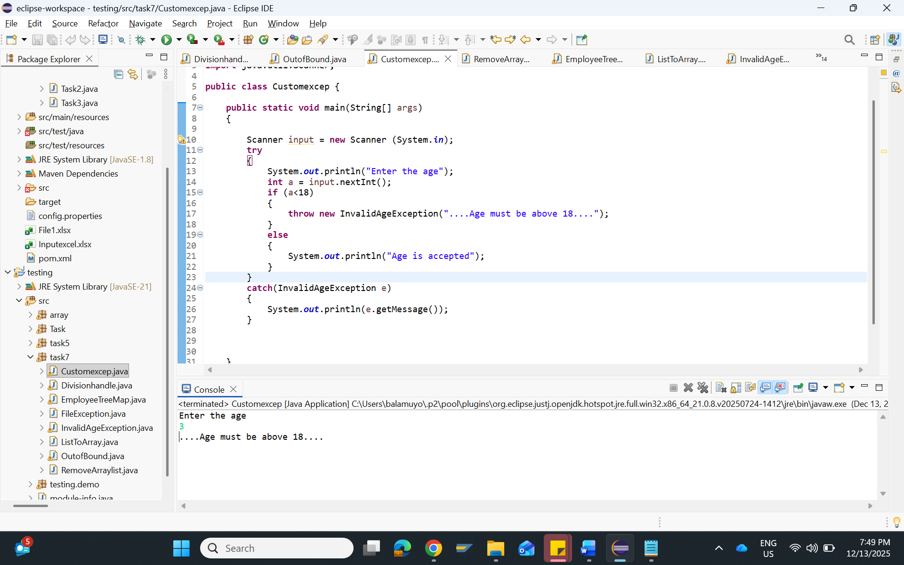

4. FileNotFoundException:
package task7;

import java.io.File;
import java.io.FileNotFoundException;
import java.util.Scanner;

public class FileException {

public static void main(String[] args) {

try
{
File file = new File ("input.txt");
Scanner scan = new Scanner (file);
while (scan.hasNextLine())
{
System.out.println(scan.nextLine());
}

scan.close();

}

catch(FileNotFoundException e) {
System.out.println("Error file not found, please check the link" +e.getMessage());
}

}
}

O/P:
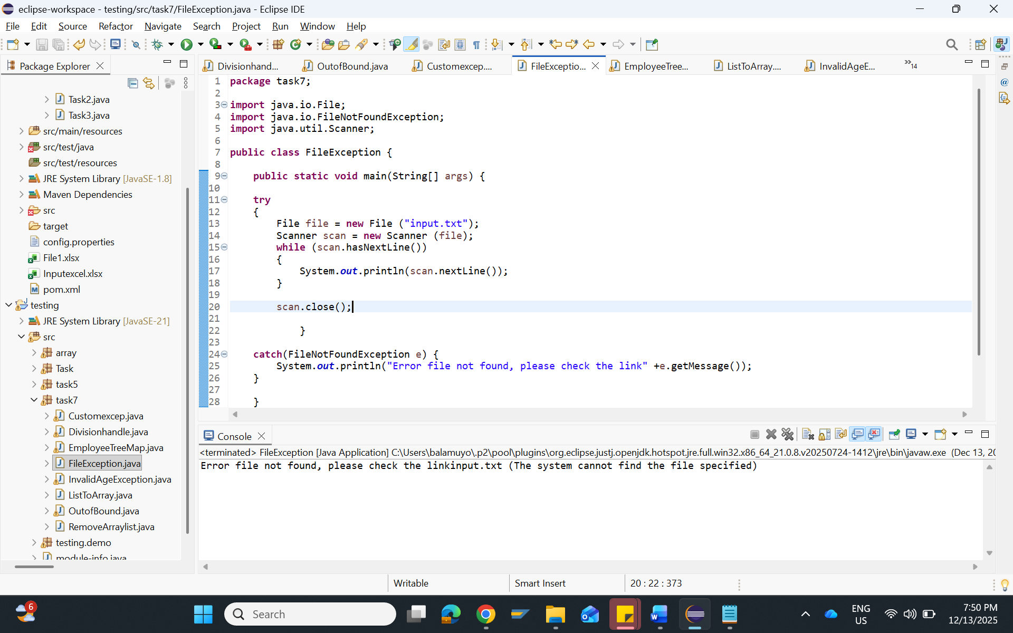

5.ArrayList
package task7;

import java.util.ArrayList;

public class RemoveArraylist {

public static void main(String[] args) {

ArrayList <String> names = new ArrayList<>();
names.add("John");
names.add("James");
names.add("Mary");
names.add("Adam");
names.add("Claire");

System.out.println("Array list before removing" + names);

names.clear();

System.out.println("Array list after removing" + names);

}

}

O/P:
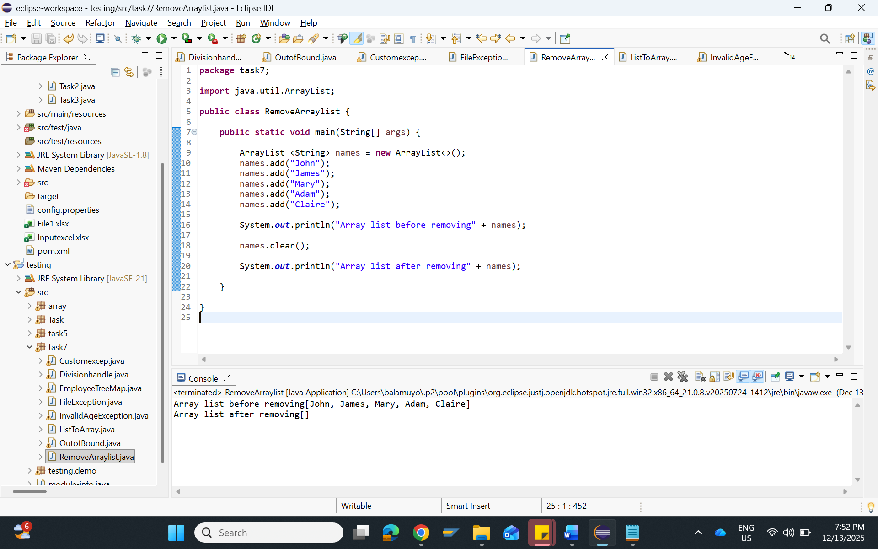
6.TreeMap
package task7;

import java.util.ArrayList;
import java.util.Collections;
import java.util.List;
import java.util.TreeMap;

public class EmployeeTreeMap {

public static void main(String[] args) {

TreeMap<Integer, String> employees = new TreeMap<>();

employees.put(101,"Ravi");
employees.put(102,"Jason");
employees.put(110, "Anita");
employees.put(117, "Balu");
employees.put(212, "Yoga");

ArrayList<String> names = new ArrayList<> (employees.values());
Collections.sort(names);

for(String name:names) {
System.out.println(name);
}

}

}
O/P:
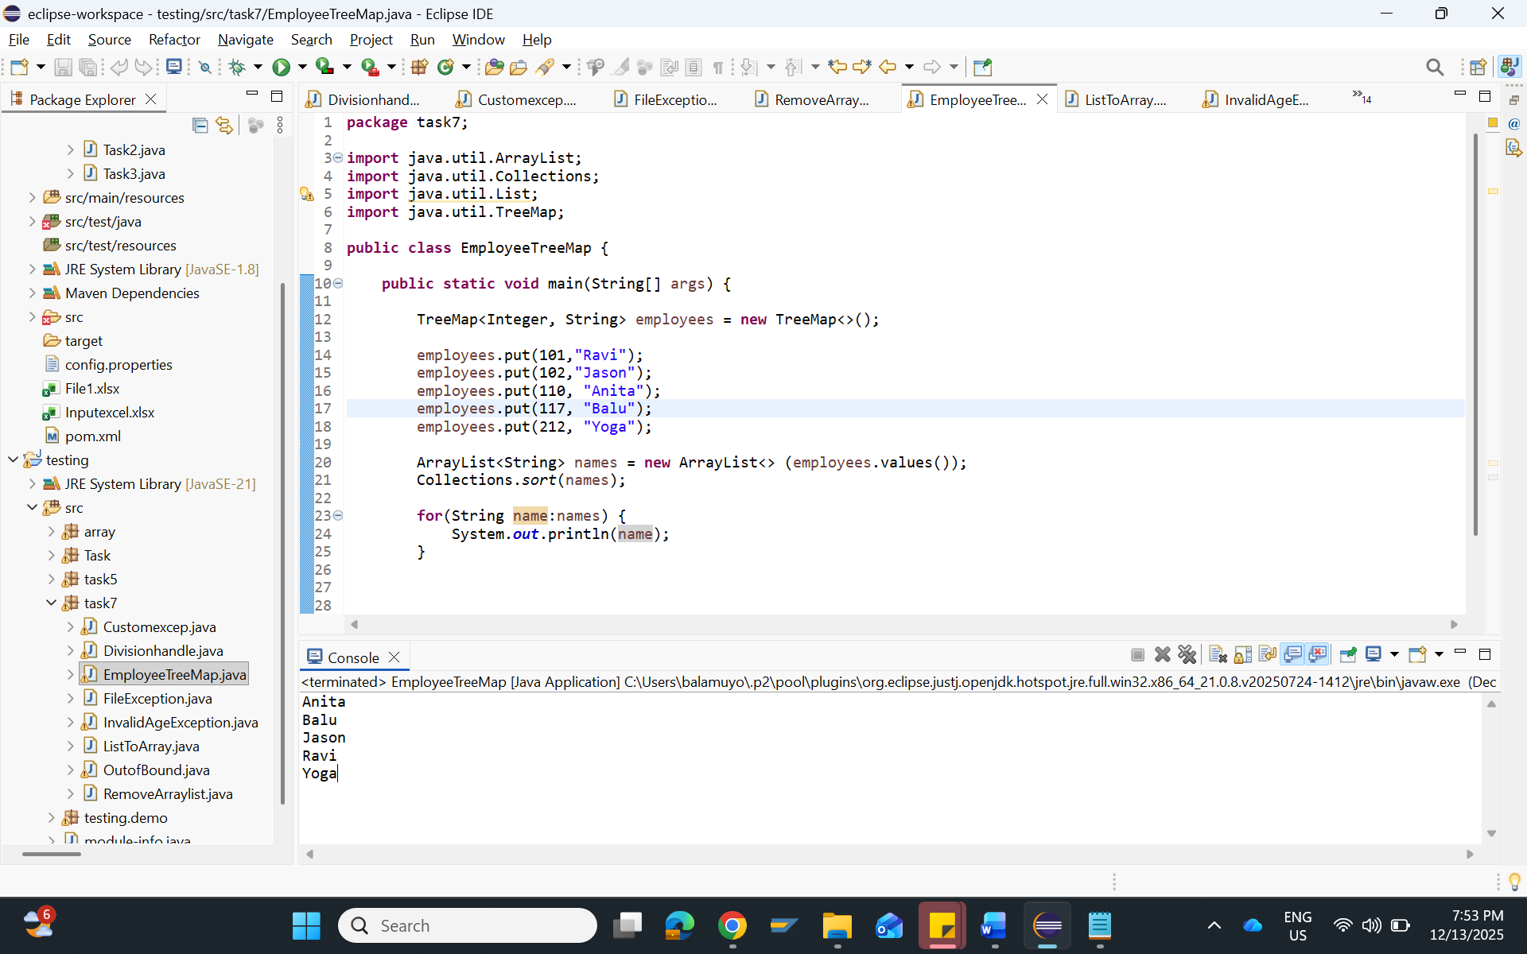

7.List to Array
package task7;

import java.util.ArrayList;

public class ListToArray {

public static void main(String[] args) {
ArrayList<String> name = new ArrayList<>();

name.add("Vihaan");
name.add("Aryan");
name.add("Balu");
name.add("Chinnu");
name.add("Zoya");

String[] array = name.toArray(new String[0]);

System.out.println("The List converted to Array names are");
for(String value:array)
{
System.out.println(value);
}

}

}

O/P:

